**RADHAKRISHNAN CHARITABLE TRUST**

**Regd. Off: 229F MISSIONARY HILL, STONE HOUSE-PO**

**UDHAGAMANDALAM-643002**

**ANNUAL REPORT 2020-2021**

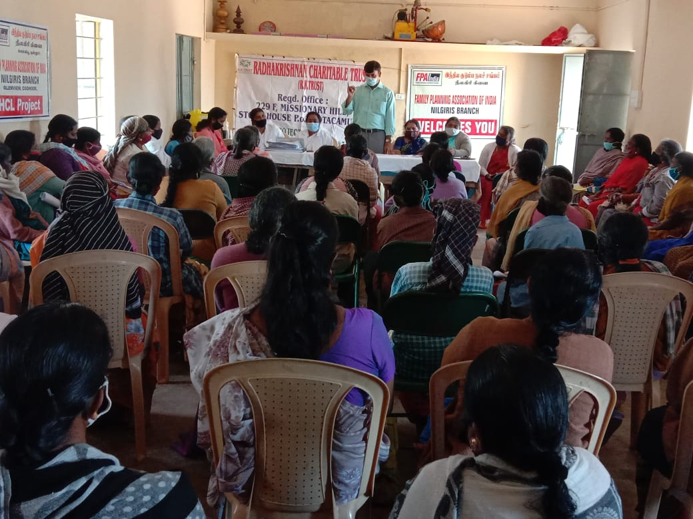

**Annual Report 2020-2021**

**Women’s Rights and GBV awareness:**

Empowering women and raising awareness of women and men on women’s rights contributes to limiting the power of gender stereotypes that prevent women from participating fully in the social, professional and public life and deprives them from their full citizenship

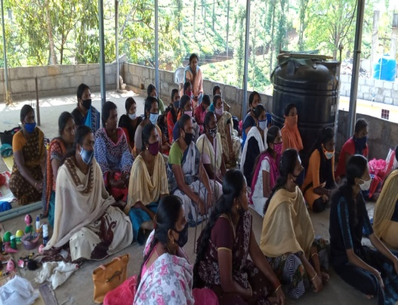 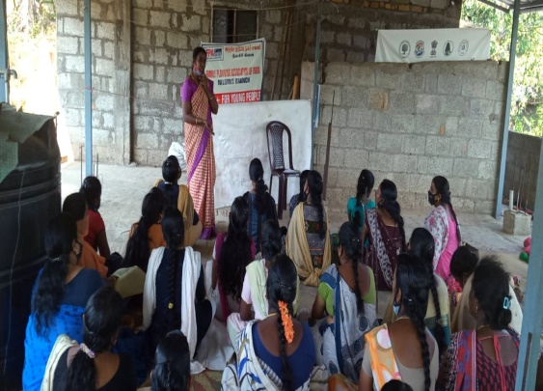

Gender equality is at the very heart of United Nations Values. Equality between men and women has been among most fundamental guarantees of human rights and protecting and promoting women’s human rights is the responsibility of all states. But millions of women around the world continue to experience discrimination. This not excluded in our target area too. Economic and social discrimination, denial of sexual and reproductive health rights, harmful gender stereotypes etc are still prevalent in the society. These awareness programmes are being conducted to dismantle the gender stereo types to enable the women to participate in the social, professional and public life. Five programmes have been organised in which 170 members participated and benefitted.

**Enrolment Campaigns:**

Government is taking continuous effort to achieve education for all. Still the tribes are not recognising the importance of education and the dropout rate is very high among the paniya tribes. 2 Campaigns have been organised during the month of April at Paniya tribal villages to enrol the school dropouts and eligible children at schools.

**Skill training:**

In order to empower vulnerable and marginalised women our skill training programme provides them with vocational and livelihood training in tailoring, aari embroidery and coconut shell products making. Coconut shell has been used to make bowls, vases, teapots, ice-cream cups, pen stand etc by cutting smoothening and carving. The making process involves various steps. This 2 month training programme was conducted by CPR Environment Education centre, Ooty. 40 beneficiaries including 10 tribal girls participated in this training.

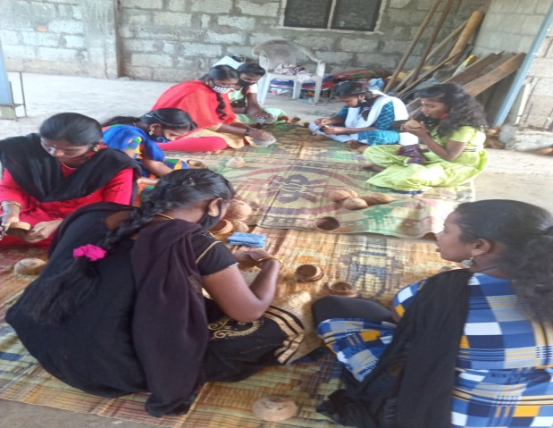 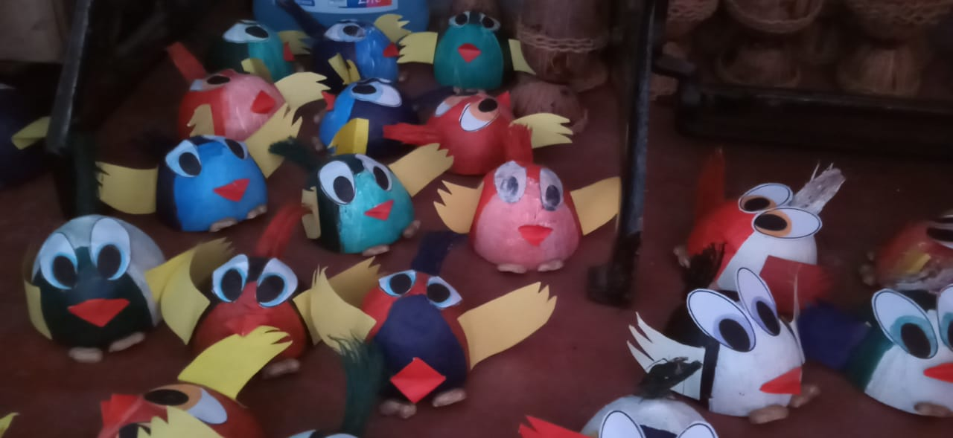

**Consumer rights awareness**:

Consumption is one of the essential economic activities. Consumers have to be aware of the commercial aspects of the sale and purchase of goods and the health and security aspect. Besides this they should be mindful of their rights and duties.

Rights and responsibilities of a consumer are dealt in detail in this camp. Right to value for money, Right to safety, Right to information, Right to choose, etc Also stressed the need of awareness on standardisation, MRP, date of manufacturing and expiry, knowledge about consumer courts

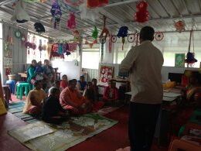 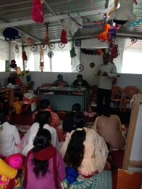

**Training on Preparation of disinfectant:**

The outbreak of Coronavirus has left everyone anxious about their safety. Initially modes of transmission were discussed in detail. After that practical session conducted on how to make disinfectant solution at home under income generation programme.This programme jointly organised with Family Planning Association of India (FPAI), Coonoor. Two such programmes organised on 15-12-2020 and 11-2-2021.

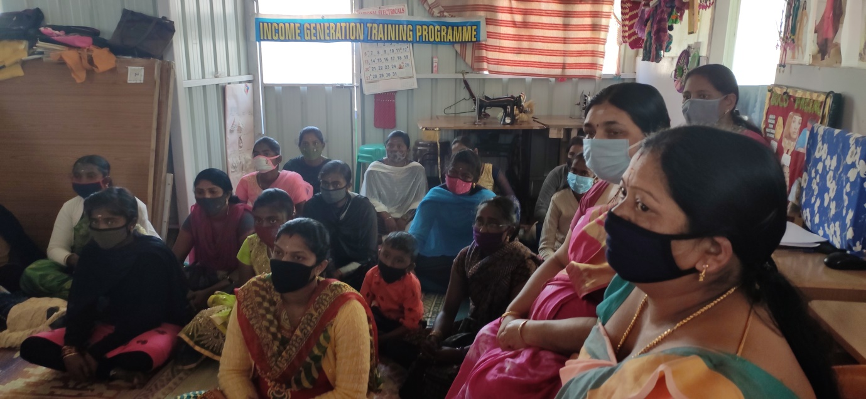

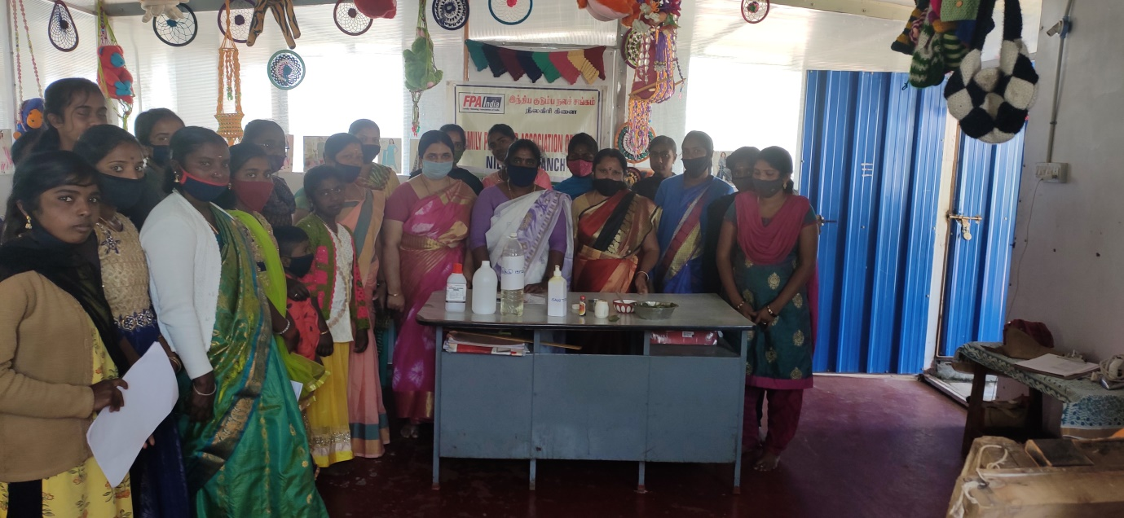

**Cancer Awareness Programme:**

Breast cancer is the most common cancer in Indian women accounting for 26.3% of all cancers in women. It is largely preventable and treatable if detected early. Yet 60% of breast cancer cases in India are diagnosed at an advanced stage. This programme was organised with the support of FPAI, Coonoor at Karimara hatty on 21-01-2021. The health nurses from FPAI stressed that all women need to be aware of how their breast normally look and feel –any change no matter how trivial it seems, deserves further evaluation by a health care professional. They also explained the symptoms of breast cancer include a lump in the breast, bloody discharge from the nipple and changes in the shape or texture of the nipple or breast and also asked the participants to visit their hospital if they have such symptoms. Finally the women expressed that the programme was very useful to them.

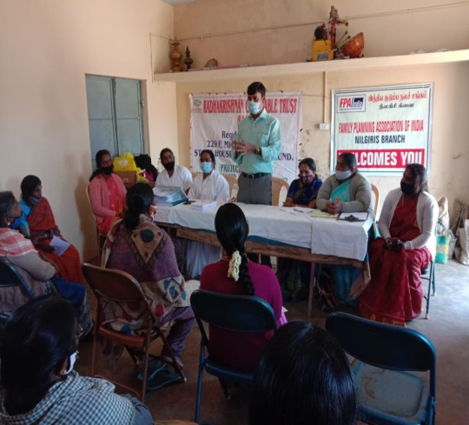 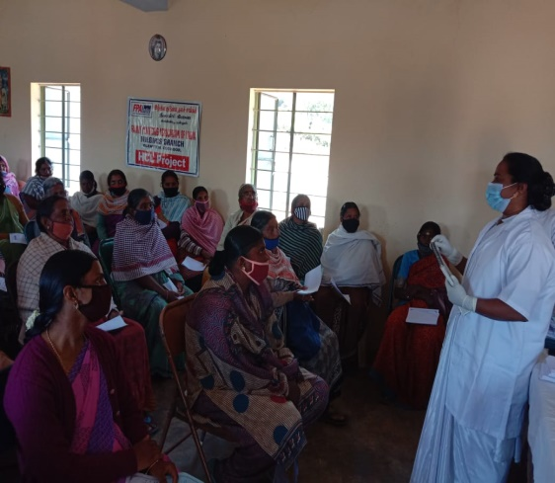

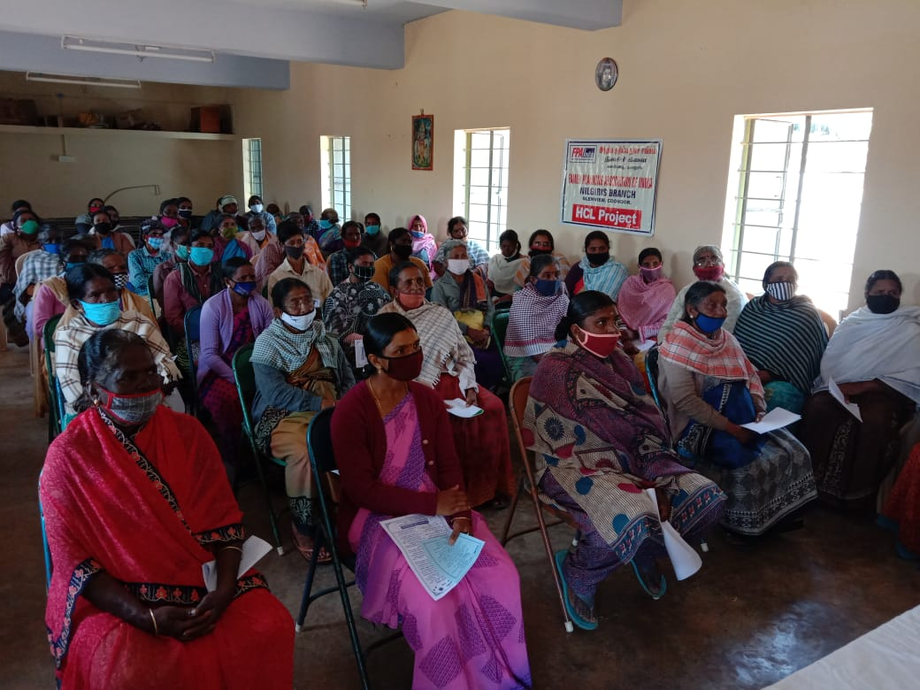

**Observation of national and international days:**

World sanitation day, National youth day, Environment day, Ambethkar jayanthi were observed to educate the general public on issues of concern, to mobilize political will and resource to address global problems, and to celebrate and reinforce achievements of humanity.

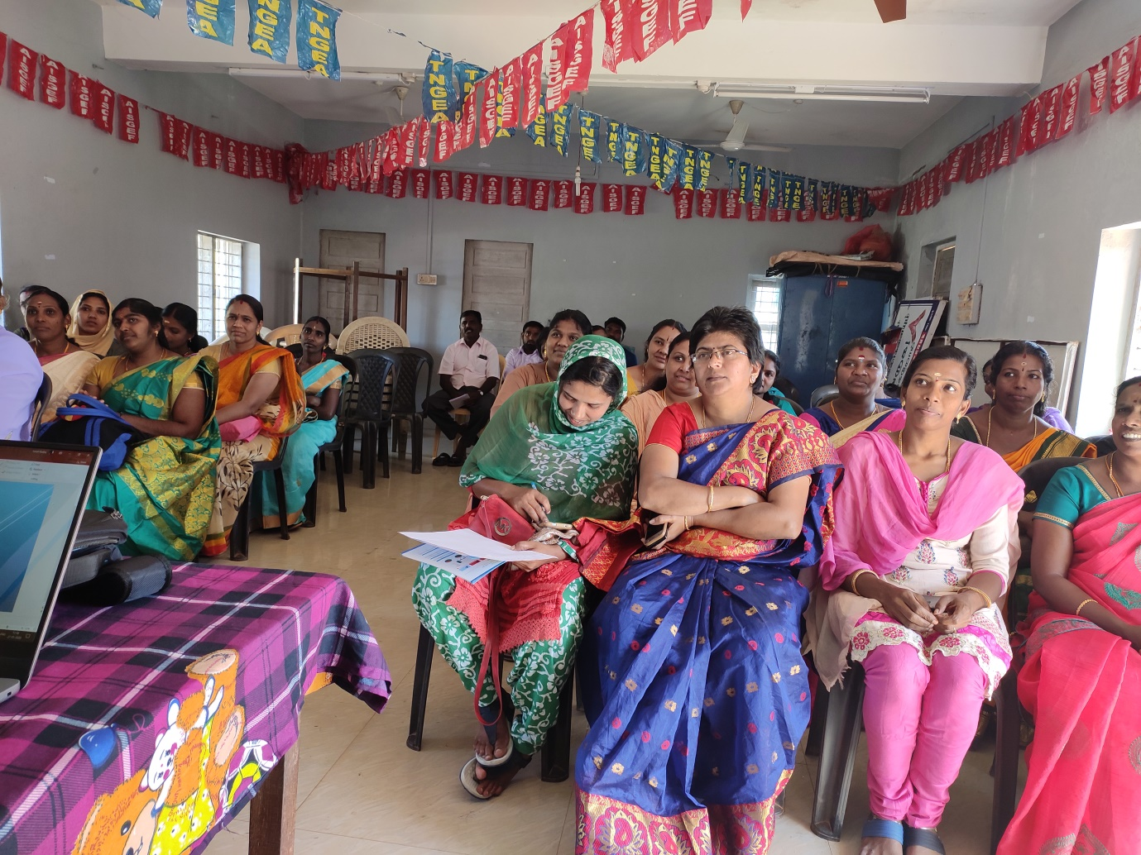

**House hold awareness on COVID-19**

Our volunteers at Coonoor conducted household awareness to prevent and create awareness among the community. They visited the houses and explained the modes of transmission like coughing and sneezing without covering mouth, coming into contact with a person who’s already carrying the virus, coming into contact with any object which contains the virus and the ways how to prevent virus infection transmission etc. This method created a great impact among the community.